Edmonton Ex-Service Women’s Branch #215

Afternoon Chilli & Social
Fundraiser
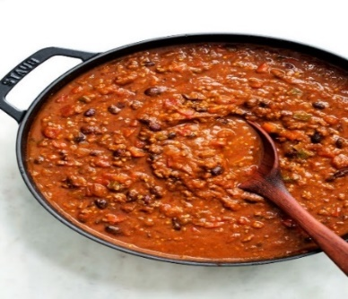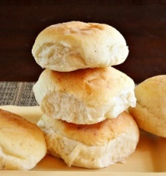
Welcome Members and Friends
Come out and join us for
chilli bowl & bun, coleslaw, drinks, desserts 50/50 Draw, Silent Auction
Bar Open

May 27th 2023, Saturday
Time: 4:00 – 8:00 pm
Price: $5.00/bowl
Location: Parkdale-Cromdale Hall
11335 – 85 St NW, some parking in back

We look forward to seeing you there!

